* Percentage is relative to …

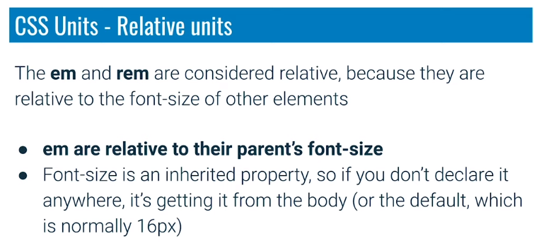

* I don’t miss around with **em** for font size. For font-size I always stick with **rem**.
* My general rule of thumb:
  + font-size = rem
  + padding and margin = em
  + width = em or percentage